Results:

The first phase of the project was to establish a reliable communication system which could send the phrase "Hello World!" without any errors. Initial hardware setup used a BJT driver circuit and an LED on the receiver side working as the photodetector. The separation between the transmitter and receiver was only about 15cm. The Arduino code used the inbuilt ADC to sample and differentiate 0s and 1s. The system could successfully transmit data at 600bps, but was limited to a size of 16 bytes.

The next phase of the project saw huge improvements in terms of distance which increased to 6m, and data size which increased to 64 bytes. The increase in transmission distance was a result of the use of a specialized photodiode. The improvements in reliability were due to a faster switching action at the transmitter side now using a MOSFET driver circuit. The data to be transmitted could now be input at runtime from the serial window, but was limited by the buffer size of the Arduino board.

The final phase of the project presents an efficient system with no limits on text size. The receiver is a three stage circuit which replaces the inbuilt Arduino ADC, making it faster. A python script is used to run the shell commands for data transfer from the PC to Arduino, and openCV for image and text file handling. Transmission of text files and image files is now possible without any loss or errors. The system now uses standard serial communication protocols to transmit data. Text files of 1Mb has been sent successfully at a speed of 9600bps, about 15 times the original speed. Uncompressed image files of size 32x32 pixels can be transmitted. However, an attempt to transmit a 64x64 image results in concatenation of a few pixel values in a row, making it unable to reconstruct the original image back from these values. These errors occur at random positions and manual correction of these values is required to reconstruct the image.

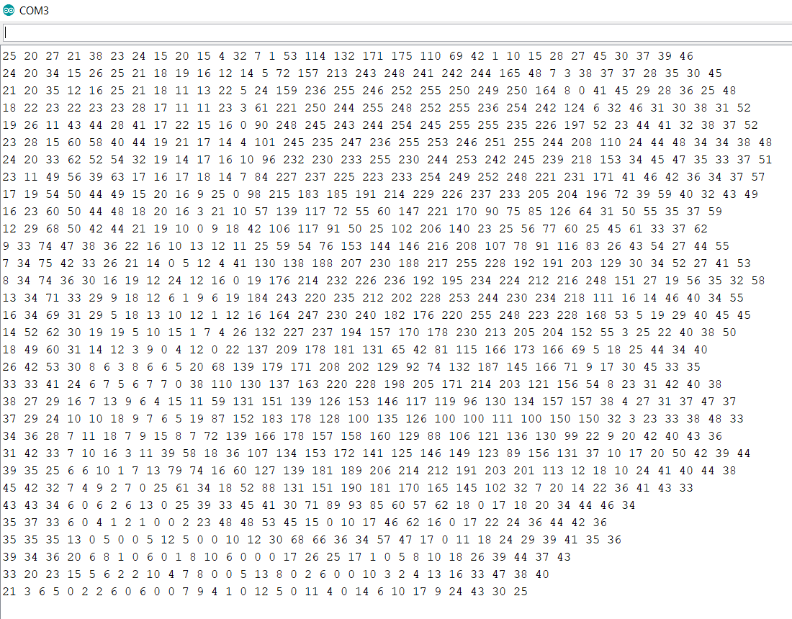

Transmitter:

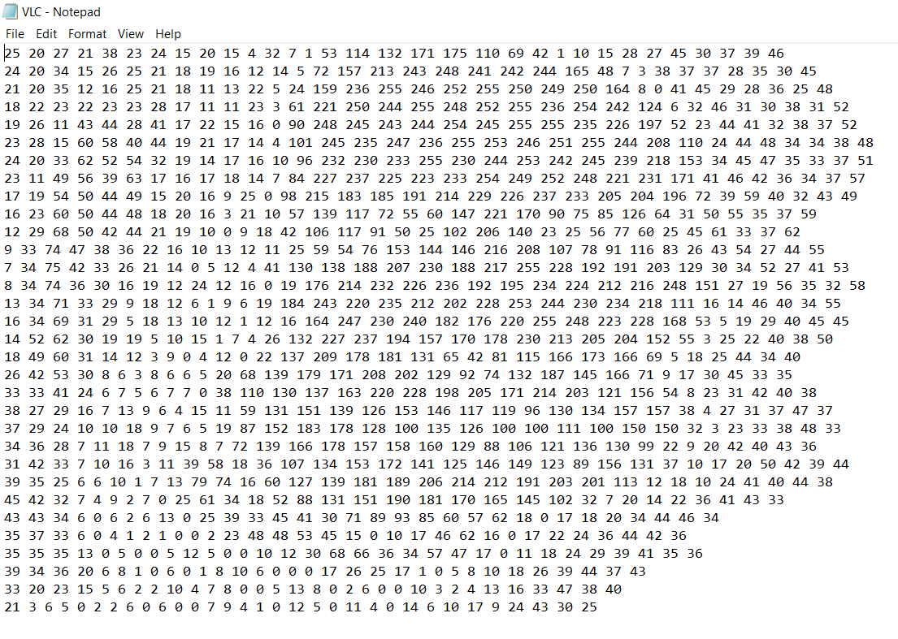

C:\Users\Ashwin TR\Dropbox\VLC 2.0\Final Report\results images\finalrpt_VLC_img.jpg

